**GMAT9600 Principles of Remote Sensing**

**Lab Demonstration:**

**Differential Radar Interferometry (DInSAR)**

DISCLAIMER

Satellite imagery and software tools provided for this assignment are for teaching GMAT9600 ONLY and hence should not be used for any other purpose. Students should delete the satellite imagery from their storage as soon as the assignment is submitted.

**Group Arrangement:**

The Computer Lab in the Civil Engineering Building Lab 201 and 611 will be used for the assignment. There will be enough computers in the lab for every student. Each student will be allocated with one computer. It is important that each student has to complete the assignment by himself/herself.

**Rules for submitting the Lab Reports and Assignments**

1. The lab reports and assignments need to be submitted by email. (For the student in GMAT9600, email to GMAT9600@geos.org.au)
2. Only one file per assignment in Word format.
3. Name your file as "StudentID-YourLastName-CoureID-*labdemo*.doc". (For example: *z3012345-Charlton-GMAT9600-labdemo.doc*).
4. Your email must have your name, student ID and the assignment name in the subject.
5. Do NOT send multiple submissions for the same assignment. If you have to re-submit, you need to request permission from the course convenor.
6. ***NOTE:******Failing to submit the file with correct format and/or naming convention will result in deduction of 1 mark.***

# 1. Introduction:

Differential radar interferometry (DInSAR) has been recognised as an effective remote sensing technique for ground deformation mapping. In general, it takes advantage of the phase differences between two synthetic aperture radar (SAR) images acquired over the same area to calculate ground surface deformation. In contrast to the point-based field surveying methods based on traditional instruments (GPS, levels, total stations, theodolites), DInSAR is capable of obtaining continuous ground deformation maps with large spatial coverage.

This lab utilises two real radar images to generate a differential interferogram of a co-seismic event. After this laboratory, you are expected to have basic understanding of DInSAR processing.

# 2. Test site:

Tibet, China

# 3. Input Data:

* Two Fine Beam Single Polarisation (FBS) ALOS PALSAR images (SLC) acquired on 29 December 2006 and 3 January 2009, respectively. The temporal baseline of this pair is 736 days while the perpendicular baseline is 446 metres.
* The corresponding interferometric phase component due to flat-earth effect.
* The corresponding topographic phase simulated from the 3-arc second SRTM DEM.

# 4. Software:

* The phase subtraction tool and the phase viewer tool developed by GEOS@UNSW.

# 5. Instructions:

1. Click “**Labdemo.zip**” from the flash and save it to the local drive, “D:\folder_name”. Unzip the zip file.
2. Two folders are contained in the zip file. They are “Software” and “Data”.

* Under the folder named as “Software”, there are 3 files:
  +  “PhaseSubtraction.exe” – the tool used to obtain the phase difference between two matrixes with complex values. Its interface is shown below.

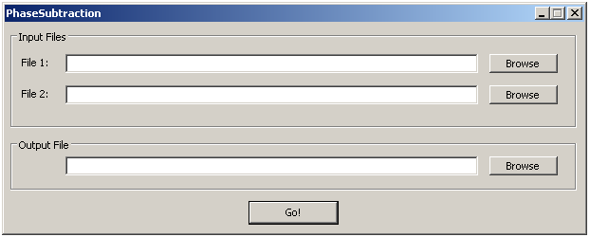

* + “sub_cmd.exe” – the background program for “PhaseSubtraction.exe”.
  +  “PhaseViewer.exe” – the tool for representing the phase information included in matrixes with complex values. Its interface is shown below.

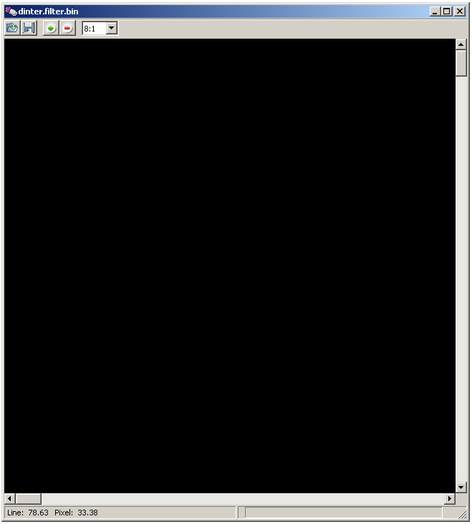

* + -  -- Open files.
    -  -- Export the opened file to “.png” image.
    -  and  -- zoom in and zoom out buttons.
* Under the folder name “Data”, there are 6 files:
  + “master.bin” – the master SLC data.
  + “slave.bin” – the slave SLC data which has been registered to the master image.
  + “master.bmp” – the intensity image of the master acquisition.
  + “slave.bmp” – the intensity image of the master acquisition.
  + “flat.bin” – the phase contribution due to flat-earth effect.
  + “topo.bin” – the simulated topographic phase contribution

1.  Open each file with the extension “.bin” by using PhaseViewer. Observe the phase information contained in each file.
2. *Raw interferogram generation*. Open “PhaseSubtraction.exe”. Set the path of “master.bin” for “File 1” and set the path of “slave.bin” for “File 2”. Next, choose the location for the output file. Click . The raw interferogram will be generated.
3. Observe the raw interferogram in PhaseViewer.  Export the raw interferogram as a “png” image.
4. *Flattened interferogram generation.* Use “PhaseSubtraction.exe”. Set the path of the raw interferogram for “File 1” and set the path of “flat.bin” for “File 2”. Next, choose the location for the output file. Click . The flattened interferogram will be produced.
5. Observe the flattened interferogram in PhaseViewer.  Export the flattened interferogram as a “png” image.
6. *Differential interfeogram generation.* Use “PhaseSubtraction.exe”. Set the path of the flattened interferogram for “File 1” and set the path of “topo.bin” for “File 2”. Next, choose the location for the output file. Click . The differential interferogram will be finally generated.
7. Observe the differential interferogram in PhaseViewer.  Export the differential interferogram as a “png” image.

**6. Questions**

A. The following figure is the SAR intensity of the master image in this lab. Please specify the along track (azimuth) direction and the range direction and discuss the reason (4 marks). *Hint: This image is in slant-range (radar) coordinate where the upper left corner is the origin (0,0).*

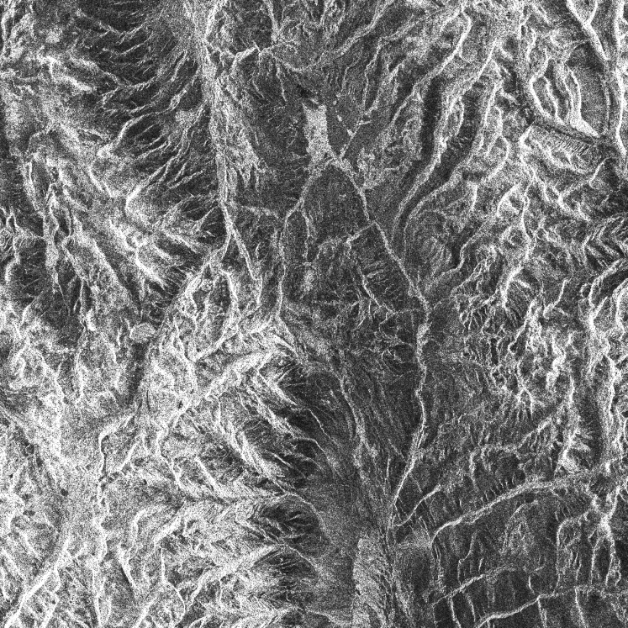

B. During the exercise, three types of products are generated: raw interferogram, flattened interferogram and differential interferogram. Please paste the corresponding image exported from the PhaseViewer in the table below (3 marks).

|  |  |
| --- | --- |
| Raw Interferogram |  |
| Flattened Interferogram |  |
| Differential Interferogram |  |

C. In this lab demo, the simulated topographic phase was obtained using SRTM DEM. The resolution of the SRTM is approximately 90 metres. The PALSAR images used in this lab were acquired in Fine Beam Single polarisation (FBS) mode. In general, the resolution of a FBS PALSAR is around 10 metres. Observe the differential interferogram carefully. Apart from the phase components due to de-correlation, atmospheric disturbances and orbital error, is there any other phase component which may contaminate the DInSAR measurement? Is it possible to further improve the DInSAR result, and if so, how? (3 marks)

**End of lab exercise.**